**What is Object repository?**

Object Repository is a collection of object and properties with which QTP will be able to recognize the objects and act on it. When a user records a test, the objects and its properties are captured by default. Without understanding objects and its properties, QTP will NOT be able to play back the scripts.

**What are types of OR?**

**Local Object Repository** - As the Name Suggests, the Object Repository is applicable only for that Action. As we know that QTP creates a New Test with 1 action by default.

**Shared Object Repository** - The Object Repository is Shared across actions/modules which would be mapped for two or more actions.

**How can we convert local OR to shared OR?**

STEP 1 Open UFT and run a test.

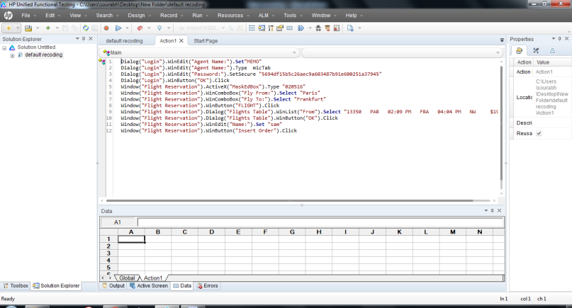

STEP 2 Then go to test OR and select or which you want to shared

STEP 3 Then click on the file menu and select export to shared or

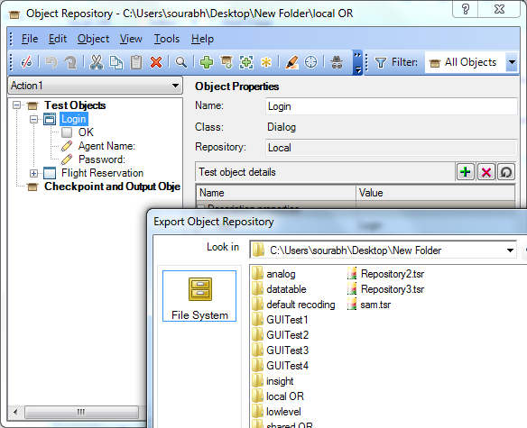

STEP 4 Then open a new test

STEP 5 Click on resource menu select on OR manager



STEP 6 Click on open window then select shared or which you want

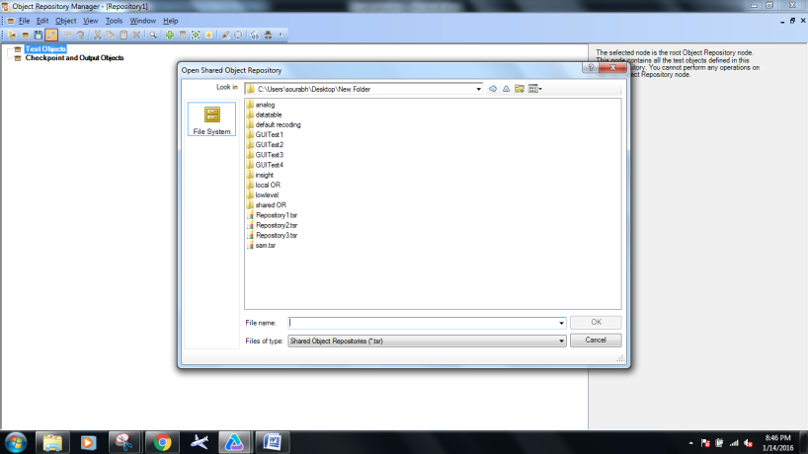

STEP 7 Then again click on resource menu select associate repositories

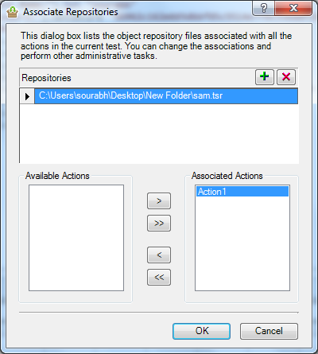

STEP 10 Then click on OR now we can see shared OR.

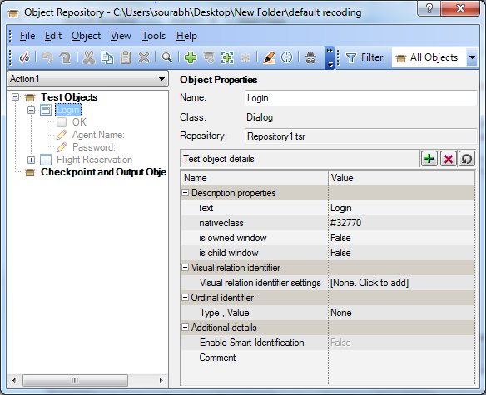

**How to merge two shared OR to one OR ?**

STEP 1 Make two different shared OR.

STEP 2 Then click on resource menu and click on OR manager.

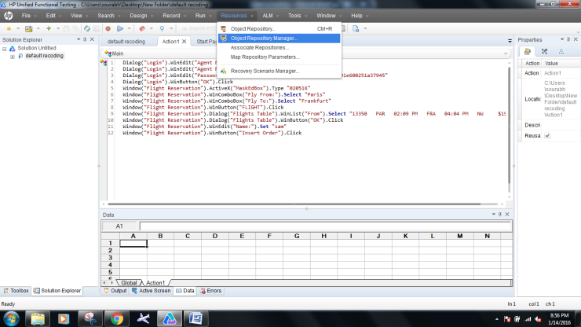

STEP 3 Click on tool menu and click on OR merge tools

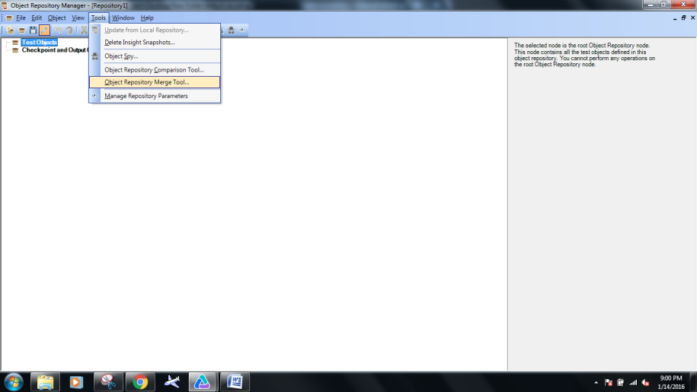

STEP 4 Then select both the OR which we want.

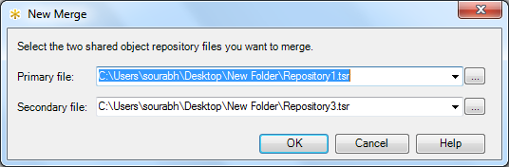

STEP 5 Then save the merge OR to new OR name and close the window.

STEP 6 Click on open button and select the shared OR.

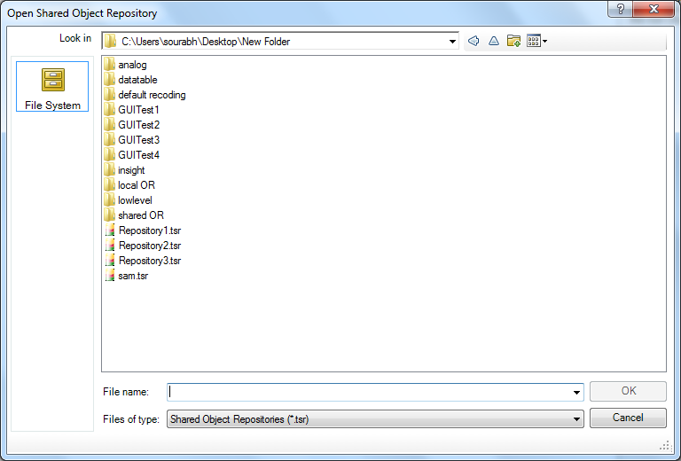

STEP 7 Then again click on resource menu select associate repositories



STEP 10 Then click on or now we can see shared or

